**E-commerce Application on IBM cloud foundry**

|  |  |
| --- | --- |
| **Date** | **1-11-2023** |
| **Team ID** | **4218** |
| **Project Name** | **E-commerce Application on IBM cloud foundry** |

|  |  |
| --- | --- |
| 1 | Problem Statement |
| 2 | Introduction |
| 3 | Lierature Survey |
| 4 | Design Thinking |
| 5 | Project Description |
| 6 | Algorithm and Techniques used |
| 7 | Software Platform |
| 8 | Coding |
| 9 | Screenshot |
| 10 | Conclusion |

**1.Problem Statement:**

Build an artisanal e-commerce platform using IBM Cloud Foundry. Connect skilled artisans with a global audience. Showcase handmade products, from exquisite jewellery to artistic home decor. Implement secure shopping carts, smooth payment gateways, and an intuitive checkout process. Nurture creativity and support small businesses through an artisan's dream marketplace!

**2.Introduction:**

In an era defined by digital transformation and global commerce, the Artisanal E-Commerce Platform emerges as an innovative initiative connecting skilled artisans with a worldwide audience. This visionary project champions craftsmanship, creativity, and entrepreneurship, providing artisans a dedicated online marketplace to exhibit their exquisite handcrafted treasures, from jewellery to home decor. With a steadfast focus on security, usability, and small business empowerment, this platform aspires to be the artisans' dream marketplace, fostering creativity and supporting entrepreneurial endeavours in the digital realm.

1. **Literature Survey**
2. **Impacts of cloud computing in India on E- commerce businesses - Ankit Jain[2023]**

The rapid adoption of cloud computing in India has had a significant impact on various industries, including E-commerce. Cloud computing offers a range of benefits to E-commerce businesses, such as scalability, cost-effectiveness, agility, and enhanced data security. This subtopic aims to explore the impacts of cloud computing on E-commerce businesses in India, focusing on the opportunities and challenges associated with its adoption. The paper will review existing literature, analyze case studies, and provide empirical evidence to shed light on how cloud computing has transformed E-commerce operations in India. The subtopic will also highlight the challenges faced by E-commerce businesses in adopting and implementing cloud computing technologies, including issues related to data privacy, security, regulatory compliance, and vendor lock-in. Furthermore, the subtopic will identify the emerging trends and future prospects of cloud computing in the Indian e-commerce landscape, and provide recommendations for e-commerce businesses to leverage cloud computing for sustained growth and competitiveness in the digital era. Overall, the subtopic will contribute to the body of knowledge on the impacts of cloud computing on e-commerce businesses in India and provide valuable insights for practitioners, policymakers, and researchers interested in the intersection of cloud computing and e-commerce in the Indian context.

1. **Design and Implementation of E-commerce Recommendation System Model Based on Cloud Computing - Cao Xuecong [2021]**

The rapid development of E-commerce has led to the accumulation of massive data, which brings challenges to the traditional recommendation system. Cloud computing provides a new way to build e-commerce recommendation system. In this paper, we propose a cloud-based E-commerce recommendation system architecture. The system consists of four layers: data layer, data analysis layer, recommendation layer, and presentation layer. The data layer stores all the data related to E-commerce, such as user information, product information, and transaction records. The data analysis layer analyzes the data in the data layer and generates features for users and products. The recommendation layer uses the features generated by the data analysis layer to recommend products to users. The presentation layer provides a user interface for users to interact with the system. It can handle massive data. It can be scaled to meet the growing demand of E-commerce. It can be customized to meet the specific needs of different E-commerce platforms.

**3. An Optimal Approach for E-Commerce Application Service on to the Public Cloud Environment - Mamta Sharma [2021]**

The paper begins by providing an overview of E-commerce and cloud computing. E-commerce is the buying and selling of goods and services over the internet. Cloud computing is a model for providing computing resources, such as servers, storage, and networking, on demand. One of the main benefits is scalability. Cloud computing can be scaled up or down to meet the changing needs of an E-commerce business. This can help businesses to save money by only paying for the resources they need. Another benefit of cloud computing is flexibility. Cloud computing can be used to deploy e-commerce applications on a variety of platforms. This can help businesses to more agile and responsive to changes in the market. This framework consists of five layers: hardware, software, resource management, server, and company. The hardware layer provides the physical infrastructure for the cloud environment. The software layer provides the operating system and middleware for the applications. The resource management layer manages the allocation of resources to the applications. The server layer provides the hosting environment for the applications.

**4. A Relationship of Cloud Computing with E-Commerce - Vaibhav P.Mujmule [2021]**

This paper explores the symbiotic relationship between cloud computing and e-commerce, investigating their integration for optimal enterprise benefits. Emphasizing cost reduction, global scalability, and heightened security, it analyzes cloud computing's impact on e-commerce applications. The classification of cloud types (public, private, community, and hybrid) is detailed, outlining their advantages. The study underscores the advantages of cost efficiency, a specialized computing environment, enhanced safety, and streamlined storage. Conversely, it addresses challenges like data privacy, security, connectivity reliance, and data storage control. This comprehensive examination provides insights for businesses navigating the dynamic landscape of cloud-based e-commerce solutions.

**5. Optimal Resource Estimation Policy Selection for E-commerce Applications in Cloud -Ms.Shahedha S [2020]**

The paper proposes a system for estimating resource requirements for cloud-based e-commerce applications. The system uses a workload generator to create a simulated workload, which is then analyzed to determine the resource requirements. The paper compares three different estimation methods: maximum likelihood, maximum product of spacing estimator, and probability weighted movements. The results show that the maximum likelihood method is the most accurate. The paper also proposes a method for generating workload for e-commerce applications. The workload is generated based on user profiles, which are used to determine the types of activities that users will perform. The paper also proposes a method for validating the workload model

**Design Thinking Approach**

**Empathize:**

Before diving into solving the problem, it's crucial to empathize with the users and understand their needs. We need to gather insights into what factors are most important to them when considering E-commerce applications.

**Actions:**

- Conduct interviews and surveys with artisans to understand their needs, challenges, and aspirations.

- Research potential customers to learn about their preferences and expectations when shopping for artisanal products.

- Analyze the existing artisanal E-commerce platforms to identify pain points and areas for improvement.

**Define:**

Based on our understanding of the problem and the users needs, we will define clear objectives and success criteria for our project

**Objectives:**

- Create a problem statement that addresses the specific challenges faced by artisans in connecting with a global audience and by customers when shopping for handmade products

- Create a user-friendly E-commerce application for best experience to the user.

**Ideate:**

Brainstorm potential solutions and approaches to address the problem. This phase involves thinking creatively and considering various algorithms and techniques for E-commerce application.

**Actions:**

- Brainstorm innovative solutions that address the defined problems.

- Encourage a diverse team to generate creative ideas for features, user interfaces, and technical solutions.

- Prioritize ideas based on their feasibility, impact, and alignment with the project's goals.

**Prototype:**

Create a prototype for E-commerce application using cloud foundry.

**Actions:**

-Develop low-fidelity prototypes ( wire frames, sketches) to visualize concepts.

- Build interactive prototypes to test user interactions and gather feedback.

**Test:**

Evaluate the prototype

**Actions:**

- Conduct user testing sessions to evaluate the prototypes and gather user feedback.

- Iterate on designs and functionalities based on user insights.

**Implement**

Develop the prototype that have passed the test.

**Actions:**

- Translate the refined prototypes into functional features and workflows.

- Implement robust security measures to protect customer and artisan data.

**Test Again**

Test again the developed prototype.

**Actions:**

- Perform comprehensive testing, including load testing, security testing, and usability testing.

- Continuously validate that the application meets user needs and adheres to quality standards.

**Launch:**

Launch the E-commerce application

**Actions**

- Deploy the E-commerce Application on IBM Cloud Foundry with a well-defined release plan.

- Promote the platform to artisans and customers through marketing and outreach efforts.

**Feedback and Iterate:**

Collect feedback from user’s and based on the feedback's collected, evaluate it accordingly.

**Actions:**

- Collect user feedback after the launch and make iterative improvements.

- Monitor the platform's performance, security, and user feedback post-launch.

**Scale and Evolve:**

Evaluate the solution for the feedback’s given by users.

**Actions:**

- Stayupdated with the latest technology trends and E-commerce best practices.

- Explore opportunities for partnerships, collaborations, and expanding the platform's offerings.

**TECHNOLOGY ARCHITECTURE:**

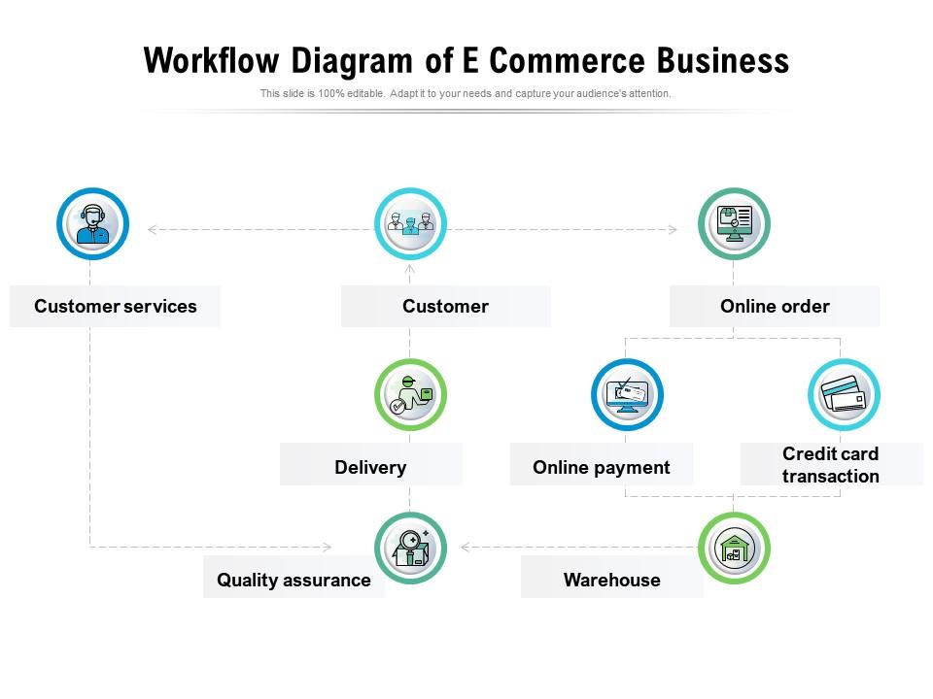

1. **Project Description:**

**Artisan Empowerment:** Provide a platform for artisans to present their unique creations to a global market, fostering creativity and entrepreneurship.

**Global Reach:** Connect artisans with a worldwide audience, breaking down geographical barriers and increasing exposure for their products.

**Product Showcase:** Enable artisans to display a diverse range of handmade products, including jewellery, home decor, clothing, and more.

**Secure Shopping Experience:** Implement robust security measures to ensure safe and secure shopping for customers, including secure payment gateways.

**User-Friendly Checkout:** Develop an intuitive and hassle-free checkout process, reducing cart abandonment rates and improving conversion.

**Community and Support:** Create a community hub that nurtures creativity, offers resources, and provides support for small businesses and artisans.

**6.Algorithm and Technology used:**

**1. Frontend Development:**

**- Technology:** HTML, CSS, JS for a dynamic and responsive user interface.

**- Implementation:** Create visually appealing product displays, intuitive navigation, and a user-friendly experience to showcase artisanal products effectively.

**2. Backend Development:**

**- Technology**: Node.js for server-side development.

**- Implementation:** Develop a robust backend to manage product listings, user profiles, and transactions. Implement RESTful APIs to connect the frontend with the backend.

**3. Database:**

**- Technology:** MongoDB for flexibility and scalability.

**- Implementation:** Store product details, user information, and transaction history. Ensure efficient retrieval for seamless user interactions.

**4. Authentication and Authorization:**

**- Technology:** flask-login for secure user authentication.

**- Implementation:** Implement a secure login/signup system, allowing artisans and customers to create accounts, manage profiles, and secure their transactions.

**5. Payment Gateway:**

**- Technology:** Stripe for secure payment processing.

**- Implementation:** Integrate Stripe API to handle payments, ensuring a smooth and secure checkout process for buyers and proper compensation for artisans.

**6. Shopping Cart:**

**- Technology:** js for state management.

**- Implementation:** Develop a responsive shopping cart that allows users to add, remove, and manage items before checkout.

**7. Image Storage:**

**- Technology:** IBM Cloud Object Storage for reliable image storage**.**

**- Implementation**: Store high-quality images of artisanal products and ensure quick retrieval for display on the platform.

**8. Deployment and Hosting:**

**- Technology:** IBM Cloud Foundry for easy deployment and scaling**.**

**- Implementation:** Deploy the application on IBM Cloud Foundry for efficient hosting, scalability, and reliability.

**9. Search and Filters:**

**- Technology:** Elasticsearch for powerful search capabilities.

**- Implementation:** Implement search functionality and filters to help users easily find specific artisanal products based on categories, materials, or artists.

**10. Feedback and Reviews:**

**- Technology:** MongoDB for storing review data.

**- Implementation:** Allow users to leave reviews and ratings for products, fostering a community-driven marketplace**.**

1. **Software Platform:**

**-IBM Cloud Foundry:** The core platform for hosting and deploying your E-commerce application.

**-Database Management System:** Choose a suitable database system like IBM Db2, MySQL, databases depending on your data structure and scalability requirements.

- **HTML Templates:** Create HTML templates for the different pages you outlined during the planning phase. Use semantic HTML elements to structure your pages effectively. Each page should have a consistent layout, including headers, footers, and navigation.

**- CSS Styling:** Write CSS styles to make your website visually appealing and in line with the design you planned. Use CSS to control fonts, colour, layout, and overall aesthetics. Consider using CSS frameworks like Bootstrap for faster development.

-**Javascript:** JavaScript is crucial in e-commerce for creating dynamic web pages, enhancing user interfaces, handling shopping carts, implementing product filtering, validating forms, and enabling real-time features like live chat and product recommendations, improving the overall shopping experience.

**-Payment Gateway Integration:** Integrate with payment gateway services such as Stripe relevant payment processor to facilitate secure transaction.

1. **Coding:**

**HTML CODE:**

<!DOCTYPE html>

<html>

<head>

<meta charset="UTF-8">

<meta name="viewport" content="width=device-width, initial-scale=1.0">

<title>Login Form</title>

<link rel="stylesheet" href="css/login.css">

</head>

<body>

<div class="wrapper">

<form action="#">

<h2>Login</h2>

<div class="input-field">

<input type="text" required>

<label>Enter your email</label>

</div>

<div class="input-field">

<input type="password" required>

<label>Enter your password</label>

</div>

<div class="forget">

<label for="remember">

<input type="checkbox" id="remember">

<p>Remember me</p>

</label>

<a href="#">Forgot password?</a>

</div>

<button type="submit">Log In</button>

<div class="register">

<p>Don't have an account? <a href="#">Register</a></p>

</div>

</form>

</div>

</body>

</html>

<html>

<head>

<link rel="stylesheet" href="css/style1.css">

<link href="https://unpkg.com/ionicons@4.5.10-0/dist/css/ionicons.min.css" rel="stylesheet">

<script src="js/app.js"></script>

</head>

<body>

<header>

<div class="logo"><a href="#">ShoPperZ</a></div>

<div class="menu">

<a href="#">

<ion-icon name="close" class="close"></ion-icon>

</a>

<ul>

<li><a href="#" class="under">HOME</a></li>

<li><a href="#" class="under">SHOP</a></li>

<li><a href="#" class="under">OUR PRODUCTS</a></li>

<li><a href="#" class="under">CONTACT US</a></li>

<li><a href="./login.html" class="under">ABOUT US</a></li>

</ul>

</div>

<div class="search">

<a href=""><input type="text" placeholder="search" id="input">

<ion-icon class="s" name="search"></ion-icon>

</a>

</div>

<div class="heading">

<ul>

<li><a href="#" class="under">HOME</a></li>

<li><a href="#" class="under">SHOP</a></li>

<li><a href="#" class="under">OUR PRODUCTS</a></li>

<li><a href="#" class="under">CONTACT US</a></li>

<li><a href="./login.html" class="under">ACCOUNT</a></li>

</ul>

</div>

<div class="heading1">

<ion-icon name="menu" class="ham"></ion-icon>

</div>

</header>

<section>

<div class="section">

<div class="section1">

<div class="img-slider">

<img src="https://images.pexels.com/photos/6347888/pexels-photo-6347888.jpeg?auto=compress&cs=tinysrgb&dpr=2&h=750&w=1260" alt="" class="img">

<img src="https://images.pexels.com/photos/3962294/pexels-photo-3962294.jpeg?auto=compress&cs=tinysrgb&dpr=2&h=750&w=1260" alt="" class="img">

<img src="https://images.pexels.com/photos/2292953/pexels-photo-2292953.jpeg?auto=compress&cs=tinysrgb&dpr=2&w=500" alt="" class="img">

<img src="https://images.pexels.com/photos/1229861/pexels-photo-1229861.jpeg?auto=compress&cs=tinysrgb&dpr=2&h=750&w=1260" alt="" class="img">

<img src="https://images.pexels.com/photos/1598505/pexels-photo-1598505.jpeg?auto=compress&cs=tinysrgb&dpr=2&h=750&w=1260" alt="" class="img">

</div>

</div>

<div class="section2">

<div class="container">

<div class="items">

<div class="img img1"><a href="./product.html"><img src="im/61HlCHJ+ORL.SX522.jpg" alt=""></a></div>

<div class="name" >vases set</div>

<div class="price">₹100</div>

<div class="info">ExclusiveLane Red Matkis Handpainted Terracotta Vases Set of 3 - Flower Vases for Home Decoration Terracotta Vase Home Decor Items for Living Room</div>

</div>

<div class="items">

<div class="img img2"><a href="./product2.html"><img src="im/81LyypbaUjL.UL1500.jpg" alt=""></a></div>

<div class="name">sasitrends</div>

<div class="price">₹500</div>

<div class="info">Sasitrends One Gram Micro Gold Plated AD Stone Mini Choker Necklace with Cute Small Earrings Traditional Jewellery Set For Women</div>

</div>

<div class="items">

<div class="img img1"><img src="https://images.pexels.com/photos/4339598/pexels-photo-4339598.jpeg?auto=compress&cs=tinysrgb&dpr=2&h=650&w=940" alt=""></div>

<div class="name">BAG</div>

<div class="price">₹1499</div>

<div class="info">Lorem ipsum dolor sit amet consectetur, adipisicing elit.</div>

</div>

<div class="items">

<div class="img img1"><img src="https://media.istockphoto.com/photos/hand-of-a-lady-selechttp://127.0.0.1:5500/product.htmlting-yellow-colored-saree-in-a-shop-picture-id1301740530" alt=""></div>

<div class="name">SAREES</div>

<div class="price">₹1999</div>

<div class="info">Lorem ipsum dolor sit amet consectetur, adipisicing elit.</div>

</div>

</div>

</div>

</div>

</section>

<footer>

<div class="footer0">

<h1>ShoPperZ</h1>

</div>

<div class="footer1 ">

Connect with us at<div class="social-media">

<a href="#">

<ion-icon name="logo-facebook"></ion-icon>

</a>

<a href="#">

<ion-icon name="logo-linkedin"></ion-icon>

</a>

<a href="#">

<ion-icon name="logo-youtube"></ion-icon>

</a>

<a href="#">

<ion-icon name="logo-instagram"></ion-icon>

</a>

<a href="#">

<ion-icon name="logo-twitter"></ion-icon>

</a>

</div>

</div>

<div class="footer2">

<div class="product">

<div class="heading">Products</div>

<div class="div">Sell your Products</div>

<div class="div">Advertise</div>

<div class="div">Pricing</div>

<div class="div">Product Buisness</div>

</div>

<div class="services">

<div class="heading">Services</div>

<div class="div">Return</div>

<div class="div">Cash Back</div>

<div class="div">Affiliate Marketing</div>

<div class="div">Others</div>

</div>

<div class="Company">

<div class="heading">Company</div>

<div class="div">Complaint</div>

<div class="div">Careers</div>

<div class="div">Affiliate Marketing</div>

<div class="div">Support</div>

</div>

<div class="Get Help">

<div class="heading">Get Help</div>

<div class="div">Help Center</div>

<div class="div">Privacy Policy</div>

<div class="div">Terms</div>

<div class="div">Login</div>

</div>

</div>

<div class="footer3">Copyright © <h4>ShoPperZ</h4> 2021-2028</div>

</footer>

<script src="https://unpkg.com/ionicons@4.5.10-0/dist/ionicons.js"></script>

<script src="js/app.js"></script>

</body>

</html>

<html lang="en">

<head>

<meta charset="UTF-8">

<meta http-equiv="X-UA-Compatible" content="IE=edge">

<meta name="viewport" content="width=device-width, initial-scale=1.0">

<link rel="stylesheet" href="css/payment.css">

</head>

<body>

<div class="container">

<form action="">

<div class="row">

<div class="col">

<h3 class="title">billing address</h3>

<div class="inputBox">

<span>full name :</span>

<input type="text" placeholder="john deo">

</div>

<div class="inputBox">

<span>email :</span>

<input type="email" placeholder="example@example.com">

</div>

<div class="inputBox">

<span>address :</span>

<input type="text" placeholder="room - street - locality">

</div>

<div class="inputBox">

<span>city :</span>

<input type="text" placeholder="mumbai">

</div>

<div class="flex">

<div class="inputBox">

<span>state :</span>

<input type="text" placeholder="india">

</div>

<div class="inputBox">

<span>zip code :</span>

<input type="text" placeholder="123 456">

</div>

</div>

</div>

<div class="col">

<h3 class="title">payment</h3>

<div class="inputBox">

<span>cards accepted :</span>

<img src="im/card_img.png" alt="">

</div>

<div class="inputBox">

<span>name on card :</span>

<input type="text" placeholder="mr. john deo">

</div>

<div class="inputBox">

<span>credit card number :</span>

<input type="number" placeholder="1111-2222-3333-4444">

</div>

<div class="inputBox">

<span>exp month :</span>

<input type="text" placeholder="january">

</div>

<div class="flex">

<div class="inputBox">

<span>exp year :</span>

<input type="number" placeholder="2022">

</div>

<div class="inputBox">

<span>CVV :</span>

<input type="text" placeholder="1234">

</div>

</div>

</div>

</div>

<input type="submit" value="proceed to checkout" class="submit-btn">

</form>

</div>

</body>

</html>

<html>

<head>

<link rel="stylesheet" href="css/style1.css">

<SCript src="js/app.js"></SCript>

</head>

<body>

<div class="logo"><a href="#">ShoPperZ</a></div>

<section class="product-details">

<div class="image-slider">

<div class="product-images">

<img src="im/61HlCHJ+ORL.SX522.jpg" class="active" alt="">

</div>

</div>

</section>

<section>

<div class="details">

<h2 class="product-brand">vases set</h2>

<p class="product-short-des">ExclusiveLane Red Matkis Handpainted Terracotta Vases Set of 3 - Flower Vases for Home Decoration Terracotta Vase Home Decor Items for Living Room</p>

<span class="product-price">₹1000</span>

<span class="product-actual-price">₹2000</span>

<span class="product-discount">( 50% off )</span>

<a href="./payment.html"><button class="btn cart-btn">buy now</button></a>

<button class="btn">add to wishlist</button>

</div>

</section>

</body>

</html>

**CSS CODE:**

* {

margin: 0;

padding: 0;

box-sizing: border-box;

font-family: "Open Sans", sans-serif;

}

body {

display: flex;

align-items: center;

justify-content: center;

min-height: 100vh;

width: 100%;

padding: 0 10px;

}

body::before {

content: "";

position: absolute;

width: 100%;

height: 100%;

background: url("../im/360_F_309869755_IquCHHxF7YABo2odctUGEjMrgVDSM8qV.jpg"), #000;

background-position: center;

background-size: cover;

}

.wrapper{

width: 400px;

border-radius: 8px;

padding: 30px;

text-align: center;

border: 1px solid rgba(255, 255, 255, 0.5);

backdrop-filter: blur(9px);

-webkit-backdrop-filter: blur(9px);

}

form {

display: flex;

flex-direction: column;

}

h2 {

font-size: 2rem;

margin-bottom: 20px;

color: #fff;

}

.input-field {

position: relative;

border-bottom: 2px solid #ccc;

margin: 15px 0;

}

.input-field label {

position: absolute;

top: 50%;

left: 0;

transform: translateY(-50%);

color: #fff;

font-size: 16px;

pointer-events: none;

transition: 0.15s ease;

}

.input-field input {

width: 100%;

height: 40px;

background: transparent;

border: none;

outline: none;

font-size: 16px;

color: #fff;

}

.input-field input:focus~label,

.input-field input:valid~label {

font-size: 0.8rem;

top: 10px;

transform: translateY(-120%);

}

.forget {

display: flex;

align-items: center;

justify-content: space-between;

margin: 25px 0 35px 0;

color: #fff;

}

#remember {

accent-color: #fff;

.forget label {

display: flex;

align-items: center;

}

.forget label p {

margin-left: 8px;

}

.wrapper a {

color: #efefef;

text-decoration: none;

}

.wrapper a:hover {

text-decoration: underline;

}

button {

background: #fff;

color: #000;

font-weight: 600;

border: none;

padding: 12px 20px;

cursor: pointer;

border-radius: 3px;

font-size: 16px;

border: 2px solid transparent;

transition: 0.3s ease;

}

button:hover {

color: #fff;

border-color: #fff;

background: rgba(255, 255, 255, 0.15);

}

.register {

text-align: center;

margin-top: 30px;

color: #fff;

}

*{

font-family: 'Poppins', sans-serif;

margin:0; padding:0;

box-sizing: border-box;

outline: none; border:none;

text-transform: capitalize;

transition: all .2s linear;

}

.container{

display: flex;

justify-content: center;

align-items: center;

padding:25px;

min-height: 100vh;

background: linear-gradient(90deg, #2ecc71 60%, #27ae60 40.1%);

}

.container form{

padding:20px;

width:700px;

background: #fff;

box-shadow: 0 5px 10px rgba(0,0,0,.1);

}

.container form .row{

display: flex;

flex-wrap: wrap;

gap:15px;

}

.container form .row .col{

flex:1 1 250px;

}

.container form .row .col .title{

font-size: 20px;

color:#333;

padding-bottom: 5px;

text-transform: uppercase;

}

.container form .row .col .inputBox{

margin:15px 0;

}

.container form .row .col .inputBox span{

margin-bottom: 10px;

display: block;

}

.container form .row .col .inputBox input{

width: 100%;

border:1px solid #ccc;

padding:10px 15px;

font-size: 15px;

text-transform: none;

}

.container form .row .col .inputBox input:focus{

border:1px solid #000;

}

.container form .row .col .flex{

display: flex;

gap:15px;

}

.container form .row .col .flex .inputBox{

margin-top: 5px;

}

.container form .row .col .inputBox img{

height: 34px;

margin-top: 5px;

filter: drop-shadow(0 0 1px #000);

}

.container form .submit-btn{

width: 100%;

padding:12px;

font-size: 17px;

background: #27ae60;

color:#fff;

margin-top: 5px;

cursor: pointer;

}

.container form .submit-btn:hover{

background: #2ecc71;

}

* {

margin: 0;

padding: 0;

box-sizing: border-box;

}

header {

display: flex;

justify-content: space-evenly;

align-items: center;

height: 60px;

width: 100%;

background: black;

}

.heading ul {

display: flex;

}

.logo a {

color: white;

transition-duration: 1s;

font-weight: 800;

}

.logo a:hover {

color: rgb(240, 197, 6);

transition-duration: 1s;

}

.heading ul li {

list-style: none;

}

.heading ul li a {

margin: 5px;

text-decoration: none;

color: black;

font-weight: 500;

position: relative;

color: white;

margin: 2px 14px;

font-size: 18px;

transition-duration: 1s;

}

.heading ul li a:active {

color: red;

}

.heading ul li a:hover {

color: rgb(243, 168, 7);

transition-duration: 1s;

}

.heading ul li a::before {

content: "";

height: 2px;

width: 0px;

position: absolute;

left: 0;

bottom: 0;

background-color: white;

transition-duration: 1s;

}

.heading ul li a:hover::before {

width: 100%;

transition-duration: 1s;

background-color: rgb(243, 168, 7);

}

#input {

height: 30px;

width: 300px;

text-decoration: none;

border: 0px;

padding: 5px;

}

.logo a {

color: white;

font-size: 35px;

font-weight: 500;

text-decoration: none;

}

ion-icon {

width: 30px;

height: 30px;

background-color: white;

color: black;

}

ion-icon:hover {

cursor: pointer;

}

.search a {

display: flex;

}

header a ion-icon {

position: relative;

right: 3px;

}

.img-slider img {

height: 720px;

width: 1080px;

}

@keyframes slide {

0% {

left: 0px;

}

15% {

left: 0px;

}

20% {

left: -1080px;

}

32% {

left: -1080px;

}

35% {

left: -2160px;

}

47% {

left: -2160px;

}

50% {

left: -3240px;

}

63% {

left: -3240px;

}

66% {

left: -4320px;

}

79% {

left: -4320px;

}

82% {

left: -5400px;

}

100% {

left: 0px;

}

}

.img-slider {

display: flex;

float: left;

position: relative;

width: 1080px;

height: 720px;

animation-name: slide;

animation-duration: 10s;

animation-iteration-count: infinite;

transition-duration: 2s;

}

.heading1 {

opacity: 0;

}

.search {

display: flex;

position: relative;

}

.section1 {

width: 1080px;

overflow: hidden;

justify-content: center;

align-items: center;

margin: 0px auto;

}

.section2 .container {

display: flex;

width: 100%;

height: max-content;

flex-wrap: wrap;

justify-content: center;

margin: 10px auto;

}

.section2 .container .items {

margin: 10px;

width: 200px;

height: 300px;

background-color: white;

border: 2.5px solid black;

border-radius: 12px;

}

.section2 .container .items .name {

text-align: center;

background-color: rgb(240, 197, 6);

height: 25px;

padding-top: 4px;

color: white;

margin: 0;

}

.section2 .container .items .price {

float: left;

padding-left: 10px;

display: block;

width: 100%;

color: rgb(255, 0, 0);

font-weight: 650;

}

.section2 .container .items .info {

padding-left: 10px;

color: rgb(243, 168, 7);

}

.section2 .container .items .img img {

width: 200px;

height: 200px;

margin: 0;

padding: 0;

border-radius: 12px;

transition-duration: 0.8s;

}

.section2 .container .items .img {

overflow: hidden;

margin: 0;

}

.section2 .container .items:hover .img img {

transform: scale(1.2);

transition-duration: 0.8s;

border-radius: 12px;

}

footer {

display: flex;

flex-direction: column;

background-color: black;

align-items: center;

color: white;

}

.footer1 {

display: flex;

flex-direction: column;

align-items: center;

color: white;

margin-top: 15px;

}

.social-media {

display: flex;

justify-content: center;

color: white;

flex-wrap: wrap;

}

.social-media a {

color: white;

margin: 20px;

border-radius: 5px;

margin-top: 10px;

color: white;

}

.social-media a ion-icon {

color: white;

background-color: black;

}

.social-media a:hover ion-icon {

color: red;

transform: translateY(5px);

}

.footer2 {

display: flex;

width: 100%;

justify-content: space-evenly;

align-items: center;

text-decoration: none;

flex-wrap: wrap;

}

.footer0 {

font-weight: 1200;

transition-duration: 1s;

}

.footer0:hover {

color: rgb(243, 168, 7);

}

.footer2 .heading {

font-weight: 900;

font-size: 18px;

}

.footer3 {

margin-top: 60px;

margin-bottom: 20px;

display: flex;

flex-wrap: wrap;

justify-content: center;

}

.footer2 .heading:hover {

color: rgb(243, 168, 7);

}

.footer2 .div:hover {

transform: scale(1.05);

}

.footer3 h4 {

margin: 0 10px;

}

.footer2 div {

margin: 10px;

}

.menu {

visibility: hidden;

}

.heading1 .ham:active {

color: red;

}

.items {

overflow: hidden;

}

.ham,

.close {

cursor: pointer;

}

@media screen and (max-width: 1250px) {

.heading ul li {

display: none;

}

.items {

transform: scale(0.9);

}

.img-slider img {

height: 60vw;

width: 80vw;

}

.ham:active {

color: red;

}

.menu {

display: flex;

flex-direction: column;

align-items: center;

}

.menu a ion-icon {

position: absolute;

}

@keyframes slide1 {

0% {

left: 0vw;

}

15% {

left: 0vw;

}

20% {

left: -80vw;

}

32% {

left: -80vw;

}

35% {

left: -160vw;

}

47% {

left: -160vw;

}

50% {

left: -240vw;

}

63% {

left: -240vw;

}

66% {

left: -320vw;

}

79% {

left: -320vw;

}

82% {

left: -400vw;

}

100% {

left: 0vw;

}

}

.menu ul {

display: flex;

flex-direction: column;

position: absolute;

width: 100vw;

height: 100vh;

background-color: black;

left: 0;

top: 0;

z-index: 11;

align-items: center;

justify-content: center;

opacity: 1;

}

.close {

z-index: 34;

color: white;

background-color: black;

}

.close:active {

color: red;

}

.menu ul li {

list-style: none;

margin: 20px;

border-top: 3px solid white;

width: 80%;

text-align: center;

padding-top: 10px;

}

.menu ul li a {

text-decoration: none;

padding-top: 10px;

color: white;

font-weight: 900;

}

.menu ul li a:hover {

color: rgb(240, 197, 6);

}

.img-slider {

display: flex;

float: left;

position: relative;

width: 80%;

height: 60%;

animation-name: slide1;

animation-duration: 10s;

animation-iteration-count: infinite;

transition-duration: 2s;

}

.section1 {

width: 80%;

overflow: hidden;

justify-content: center;

align-items: center;

margin: 0px auto;

}

.heading1 {

opacity: 1;

position: relative;

bottom: 8px;

}

.search a {

display: flex;

flex-wrap: nowrap;

}

.heading1 .ham {

background-color: black;

color: white;

}

#input {

width: 200px;

flex-shrink: 2;

}

header {

height: 150px;

}

}

@media screen and (max-width: 550px) {

.heading ul li {

display: none;

}

.heading1 {

opacity: 1;

bottom: 8px;

}

header {

height: 250px;

flex-wrap: wrap;

display: flex;

flex-direction: column;

}

#input {

width: 150px;

}

.close {

z-index: 34;

}

.search a {

display: flex;

flex-wrap: nowrap;

}

}

.product-details{

width: 100%;

padding: 60px 10vw;

display: flex;

justify-content: space-between;

}

.image-slider{

width: 500px;

height: 500px;

position: relative;

background-image: url('../im/61HlCHJ+ORL.SX522.jpg');

background-size: cover;

}

.product-images{

position: absolute;

bottom: 20px;

left: 50%;

transform: translateX(-50%);

width: 90%;

background: #fff;

border-radius: 5px;

display: grid;

grid-template-columns: repeat(4, 1fr);

height: 100px;

grid-gap: 10px;

padding: 10px;

}

.product-images img{

width: 100%;

height: 80px;

object-fit: cover;

cursor: pointer;

}

.product-images img.active{

opacity: 0.5;

}

.details{

width: 50%;

}

.details .product-brand{

text-transform: capitalize;

font-size: 30px;

}

.details .product-short-des{

font-size: 25px;

line-height: 30px;

height: auto;

margin: 15px 0 30px;

}

.product-price{

font-weight: 700;

font-size: 30px;

}

.product-actual-price{

font-size: 30px;

opacity: 0.5;

text-decoration: line-through;

margin: 0 20px;

font-weight: 300;

}

.product-discount{

color: #ff7d7d;

font-size: 20px;

}

.product-sub-heading{

font-size: 30px;

text-transform: uppercase;

margin: 60px 0 10px;

font-weight: 300;

}

.size-radio-btn{

display: inline-block;

width: 80px;

height: 80px;

text-align: center;

font-size: 20px;

border: 1px solid #383838;

border-radius: 50%;

margin: 10px;

margin-left: 0;

line-height: 80px;

text-transform: uppercase;

color: #383838;

cursor: pointer;

}

.size-radio-btn.check{

background: #383838;

color: #fff;

}

.btn{

width: 48%;

padding: 20px;

border-radius: 5px;

background: none;

border: 1px solid #383838;

color: #383838;

font-size: 20px;

cursor: pointer;

margin: 20px 0;

text-transform: capitalize;

}

.cart-btn{

margin-right: 2%;

background: #383838;

color: #fff;

}

**JS CODE:**

const close = document.querySelector(".close");

const open = document.querySelector(".ham");

const menu = document.querySelector(".menu");

close.addEventListener("click", () => {

menu.style.visibility = "hidden";

});

open.addEventListener("click", () => {

menu.style.visibility = "visible";

});

const productImages = document.querySelectorAll(".product-images img");

const productImageSlide = document.querySelector(".image-slider");

let activeImageSlide = 0;

productImages.forEach((item, i) => {

item.addEventListener('click', () => {

productImages[activeImageSlide].classList.remove('active');

item.classList.add('active');

productImageSlide.style.backgroundImage = `url('${item.src}')`;

activeImageSlide = i;

})

})

const sizeBtns = document.querySelectorAll('.size-radio-btn');

let checkedBtn = 0;

sizeBtns.forEach((item, i) => {

item.addEventListener('click', () => {

sizeBtns[checkedBtn].classList.remove('check');

item.classList.add('check');

checkedBtn = i;

})

})

const addToCartButtons = document.querySelectorAll('.product button');

const cartItemsContainer = document.querySelector('.cart-items');

addToCartButtons.forEach(button => {

button.addEventListener('click', () => {

const product = button.parentElement;

const productName = product.querySelector('h3').textContent;

const productPrice = parseFloat(product.querySelector('p').textContent.slice(

const cartItem = document.createElement('div');

cartItem.classList.add('cart-item');

cartItem.innerHTML = `

<p>${productName}</p>

<p>$${productPrice.toFixed(2)}</p>

<button class="remove-item">Remove</button>`;

cartItemsContainer.appendChild(cartItem);

const cartTotal = document.querySelector('#cart p');

const currentTotal = parseFloat(cartTotal.textContent.slice(7));

const newTotal = currentTotal + productPrice;

cartTotal.textContent = `Total: $${newTotal.toFixed(2)}`;});});

cartItemsContainer.addEventListener('click', event => {

if (event.target.classList.contains('remove-item')) {

const cartItem = event.target.parentElement;

const itemPrice = parseFloat(cartItem.querySelector('p:nth-child(2)').textCont

const cartTotal = document.querySelector('#cart p');

const currentTotal = parseFloat(cartTotal.textContent.slice(7));

const newTotal = currentTotal - itemPrice;

cartTotal.textContent = `Total: $${newTotal.toFixed(2)}`;

cartItem.remove();

JAVASCRIPT

}

});

**9.Screenshot:**

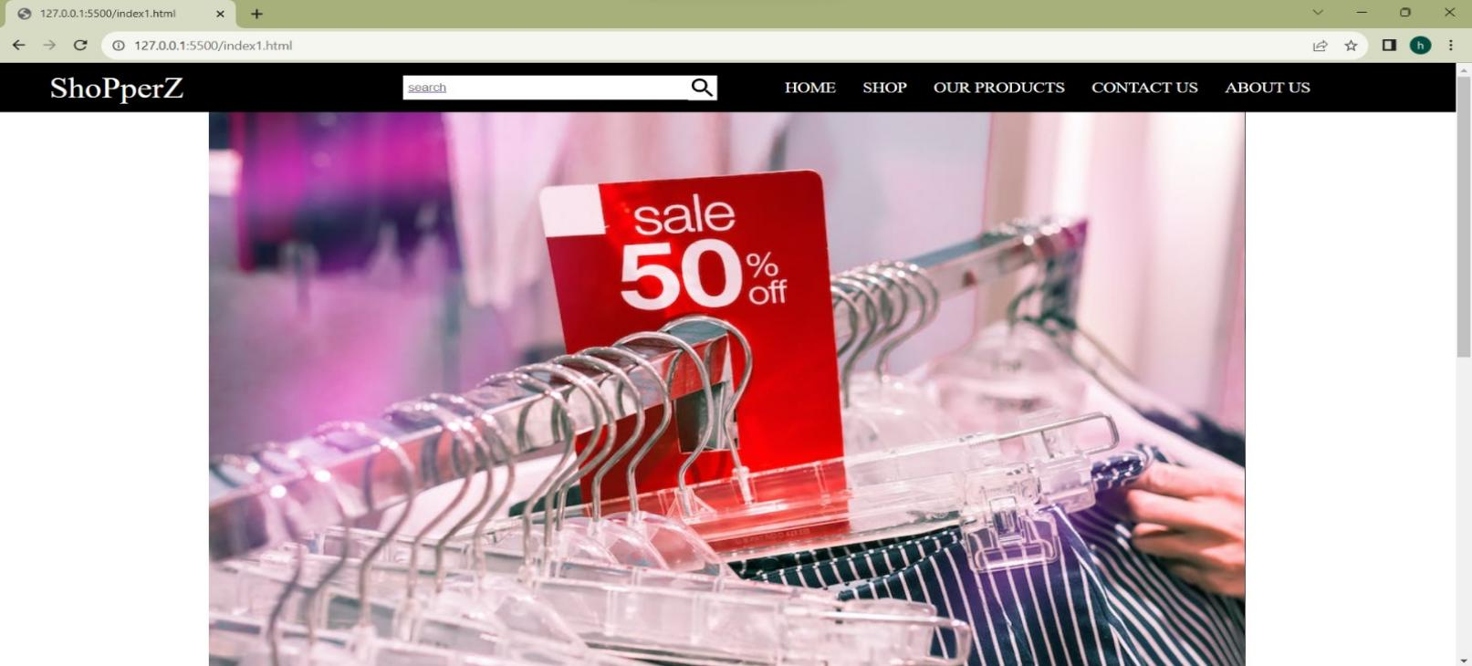

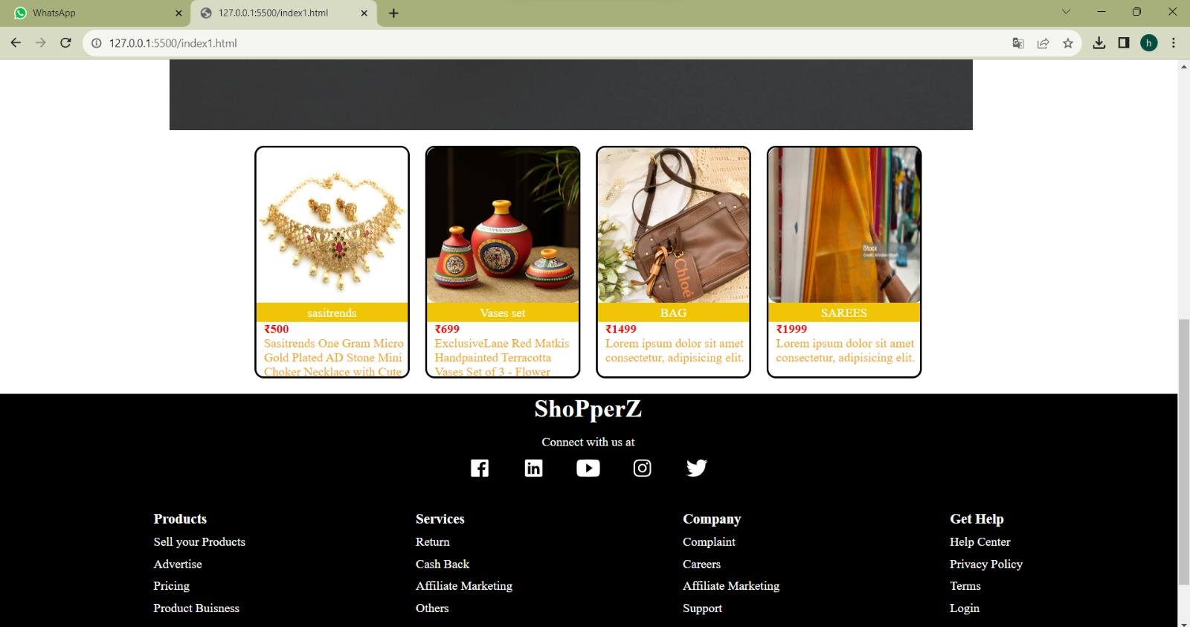

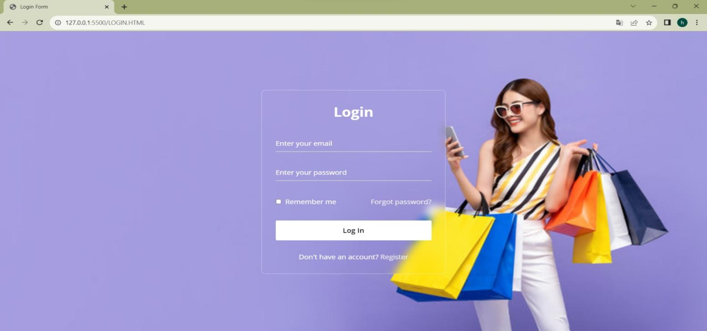

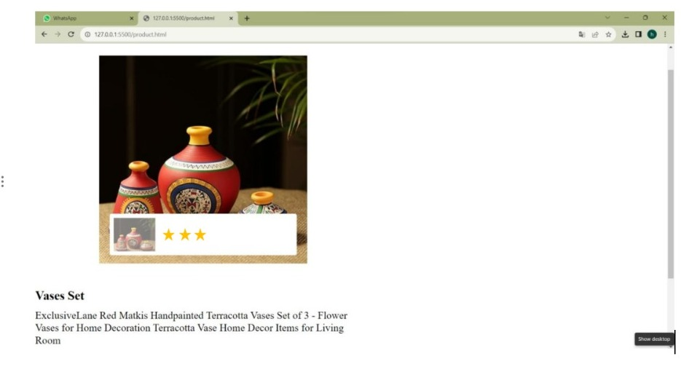

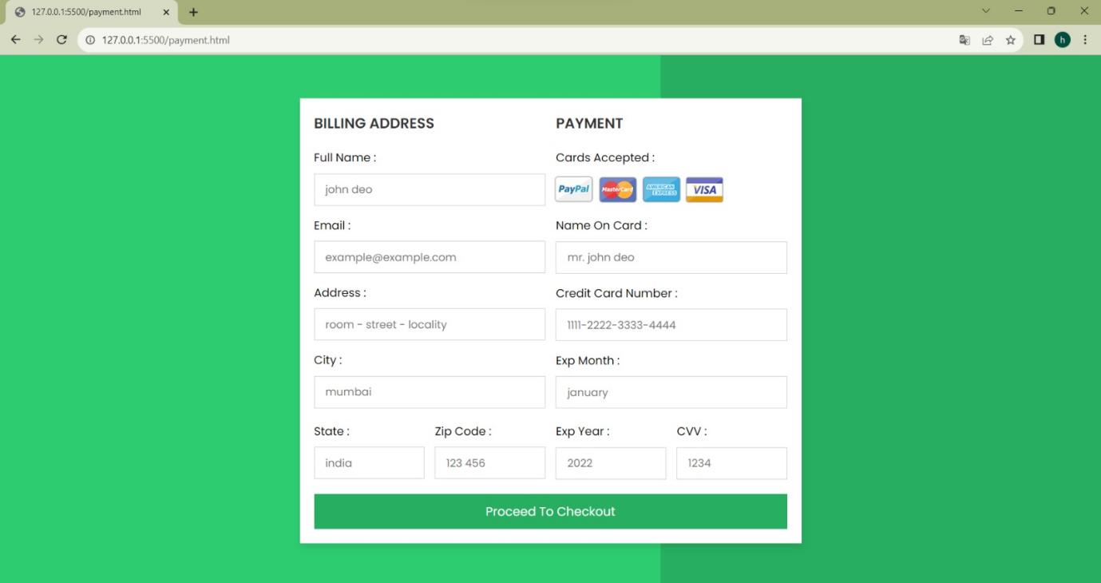

**10.Conclusion:**

The Artisanal E-Commerce Platform on IBM Cloud Foundry is poised to create a transformative space for artisans and customers, fostering creativity, connecting cultures, and empowering small businesses. With secure shopping, intuitive design, and a supportive community, it aims to be the artisan's dream marketplace, promoting craftsmanship and artistic expression on a global scale